Test Case: tc003_SPX_Dev5_Crear_Requisicion_Spot_Tipo_Cobro_CC_Urgent
Step 1 - Enter username and password and click to button Enter : Credentials Entered
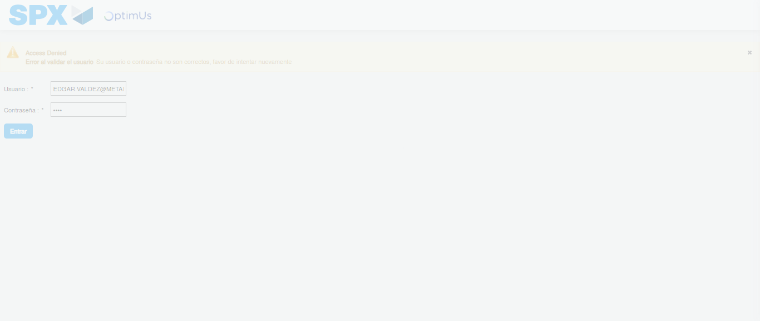Image file-name: QC_Testing-tc003_SPX_Dev5_Crear_Requisicion_Spot_Tipo_Cobro_CC_Urgent-1781571922571

Step 2 - Select to UEN and Access to Spot Buy Requisitions : UEN Correctly selected and Correct access
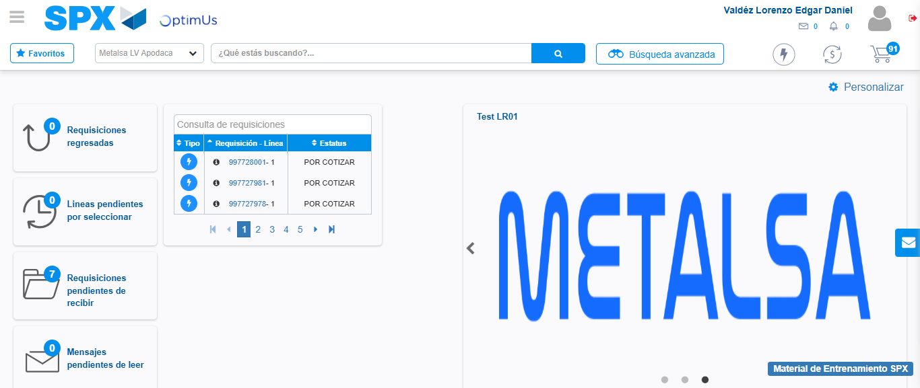Image file-name: QC_Testing-tc003_SPX_Dev5_Crear_Requisicion_Spot_Tipo_Cobro_CC_Urgent-1781571949088

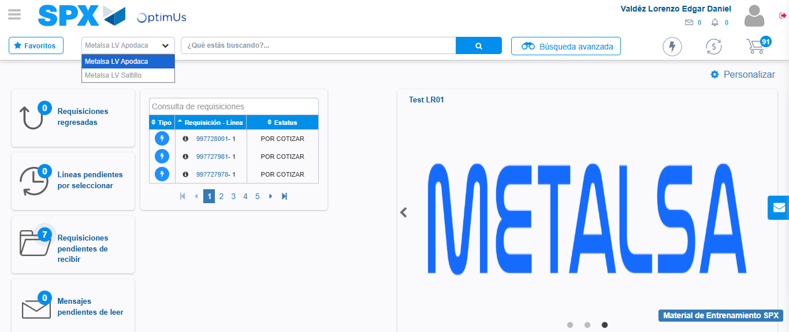Image file-name: QC_Testing-tc003_SPX_Dev5_Crear_Requisicion_Spot_Tipo_Cobro_CC_Urgent-1781571951604

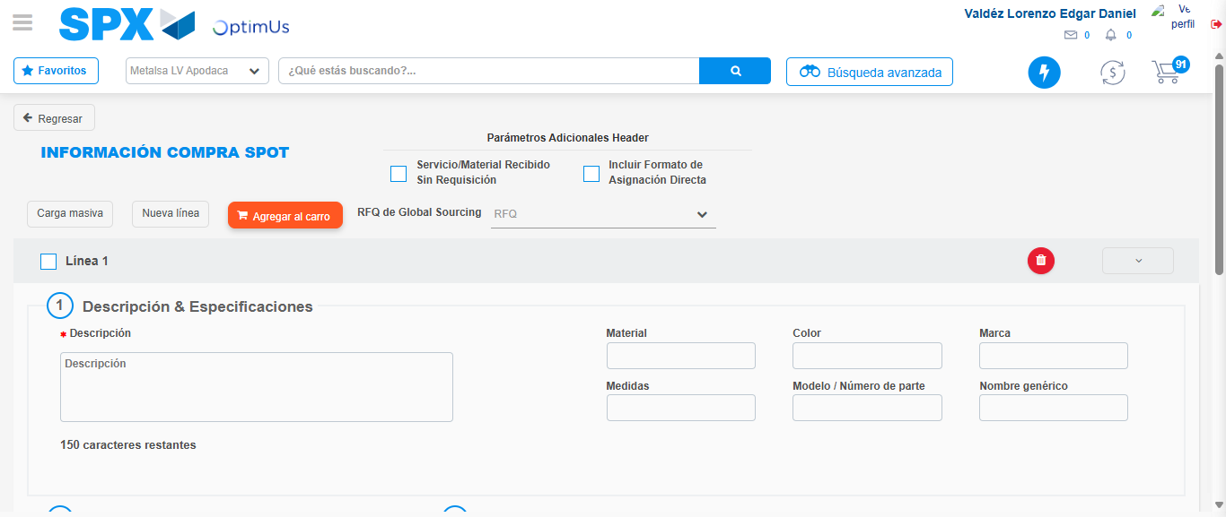Image file-name: QC_Testing-tc003_SPX_Dev5_Crear_Requisicion_Spot_Tipo_Cobro_CC_Urgent-1781571970530

Step 3 - Data Capture Spot Buy Requisition: Data captured correctly
Image file-name: QC_Testing-tc003_SPX_Dev5_Crear_Requisicion_Spot_Tipo_Cobro_CC_Urgent-1781571970766

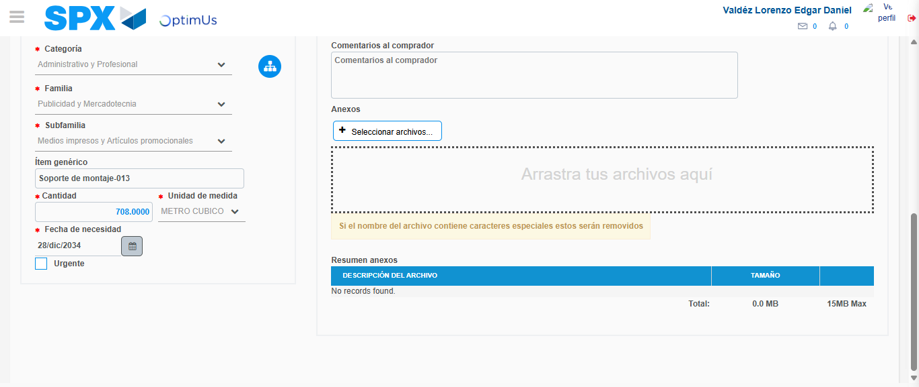Image file-name: QC_Testing-tc003_SPX_Dev5_Crear_Requisicion_Spot_Tipo_Cobro_CC_Urgent-1781571982113

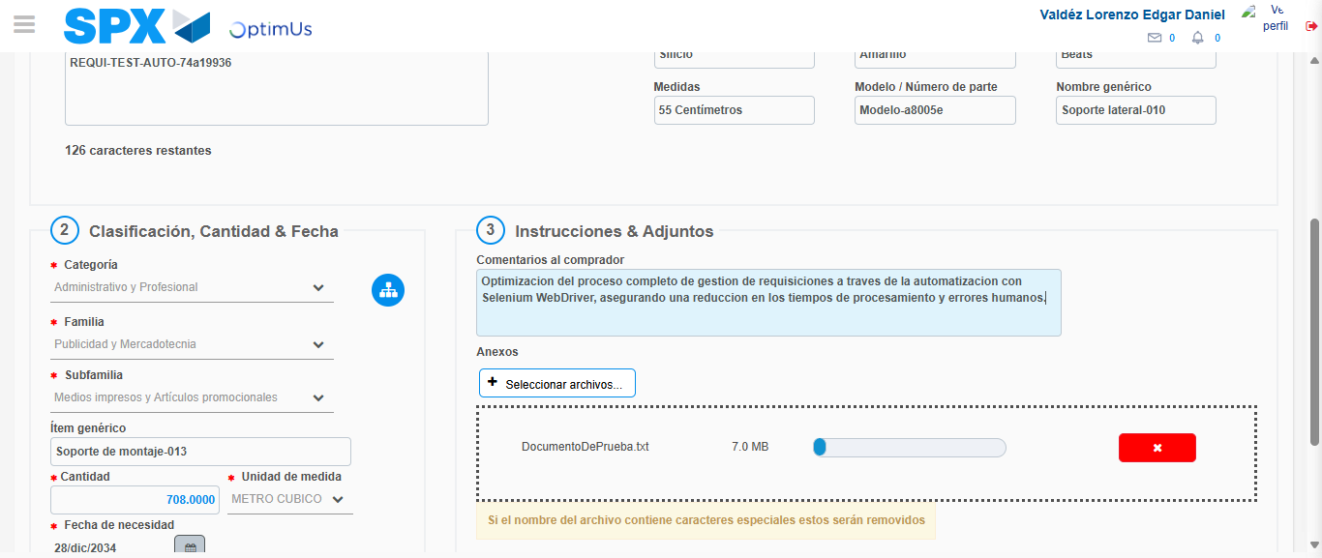Image file-name: QC_Testing-tc003_SPX_Dev5_Crear_Requisicion_Spot_Tipo_Cobro_CC_Urgent-1781571982893

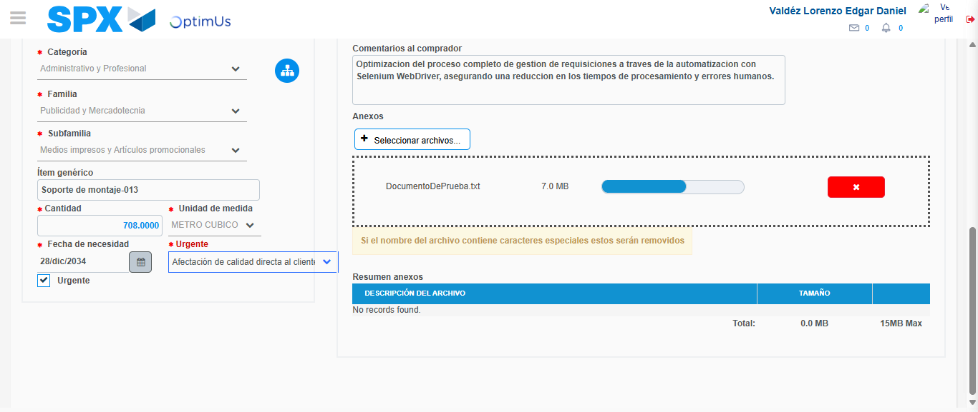Image file-name: QC_Testing-tc003_SPX_Dev5_Crear_Requisicion_Spot_Tipo_Cobro_CC_Urgent-1781571986443

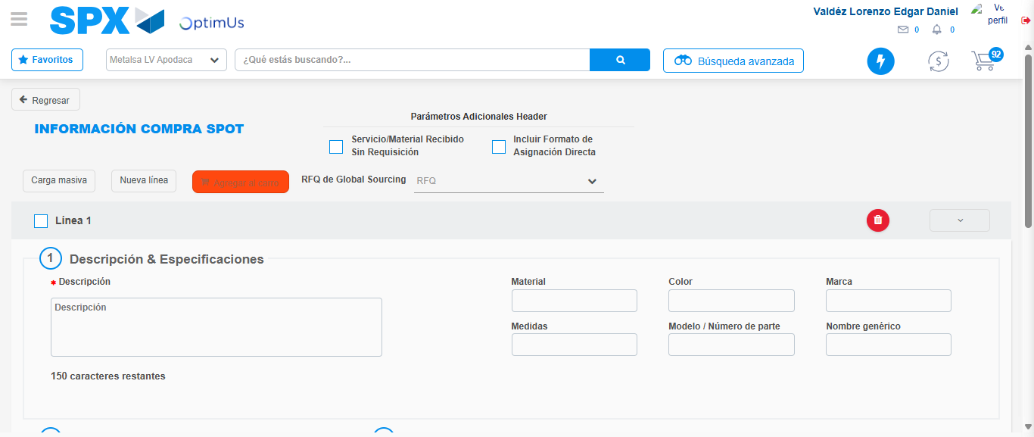Image file-name: QC_Testing-tc003_SPX_Dev5_Crear_Requisicion_Spot_Tipo_Cobro_CC_Urgent-1781571990454

Step 4 - Select to Requisition: Requisition Correctly selected
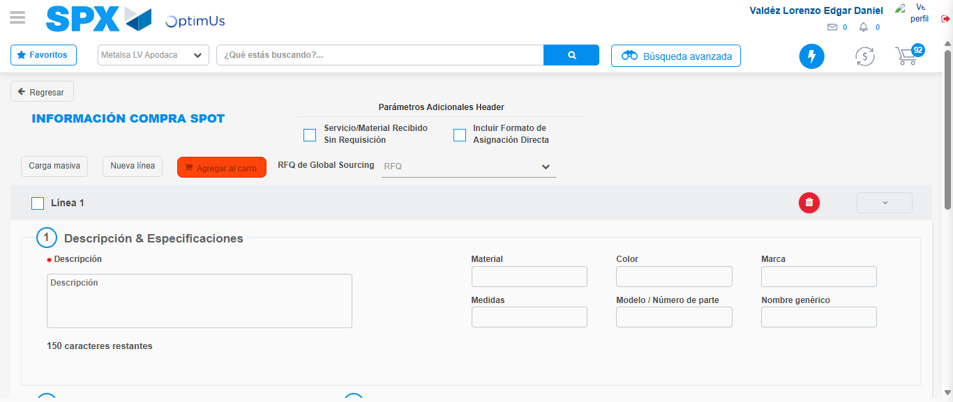Image file-name: QC_Testing-tc003_SPX_Dev5_Crear_Requisicion_Spot_Tipo_Cobro_CC_Urgent-1781571990647

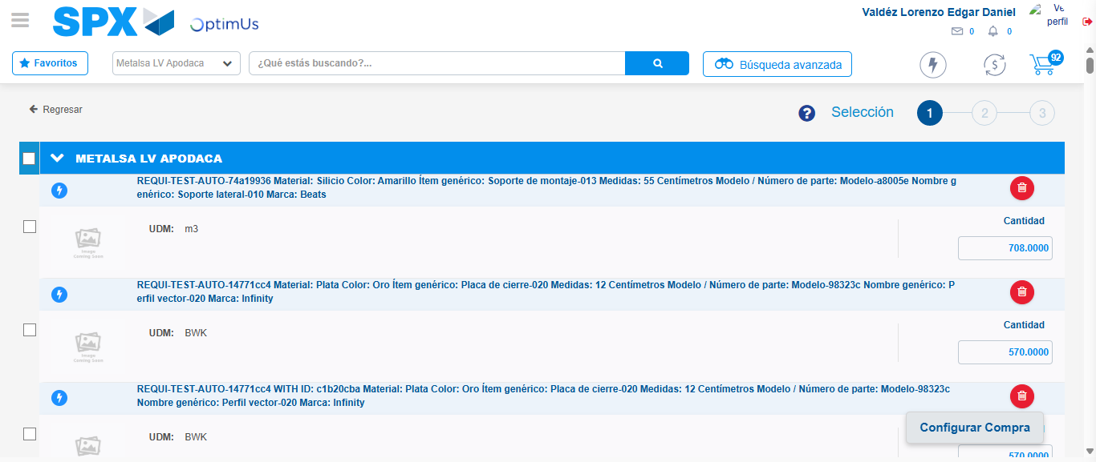Image file-name: QC_Testing-tc003_SPX_Dev5_Crear_Requisicion_Spot_Tipo_Cobro_CC_Urgent-1781571999662

Image file-name: QC_Testing-tc003_SPX_Dev5_Crear_Requisicion_Spot_Tipo_Cobro_CC_Urgent-1781571999913

Image file-name: QC_Testing-tc003_SPX_Dev5_Crear_Requisicion_Spot_Tipo_Cobro_CC_Urgent-1781572000092

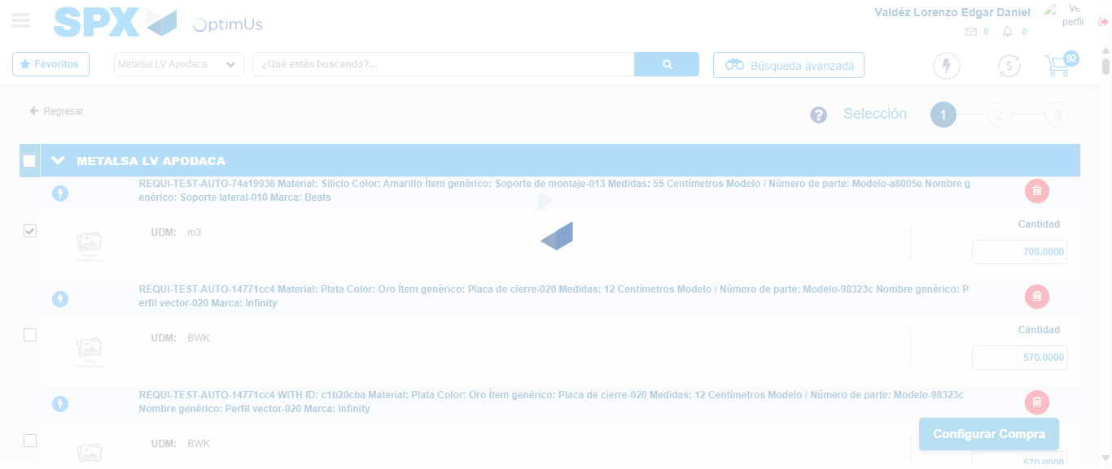Image file-name: QC_Testing-tc003_SPX_Dev5_Crear_Requisicion_Spot_Tipo_Cobro_CC_Urgent-1781572001031

Step 5 - Select Type Account For Requisition: Type Account Correctly selected
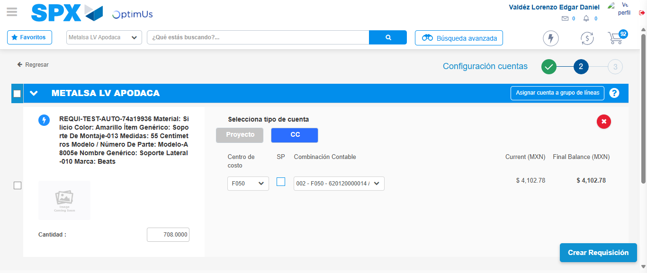Image file-name: QC_Testing-tc003_SPX_Dev5_Crear_Requisicion_Spot_Tipo_Cobro_CC_Urgent-1781572013642

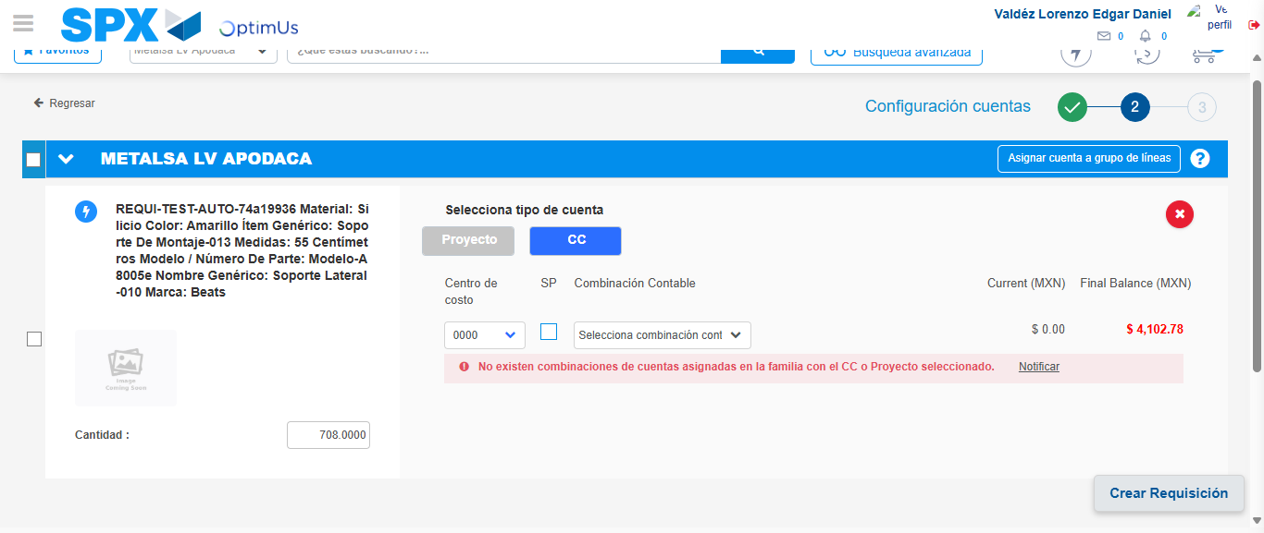Image file-name: QC_Testing-tc003_SPX_Dev5_Crear_Requisicion_Spot_Tipo_Cobro_CC_Urgent-1781572024231

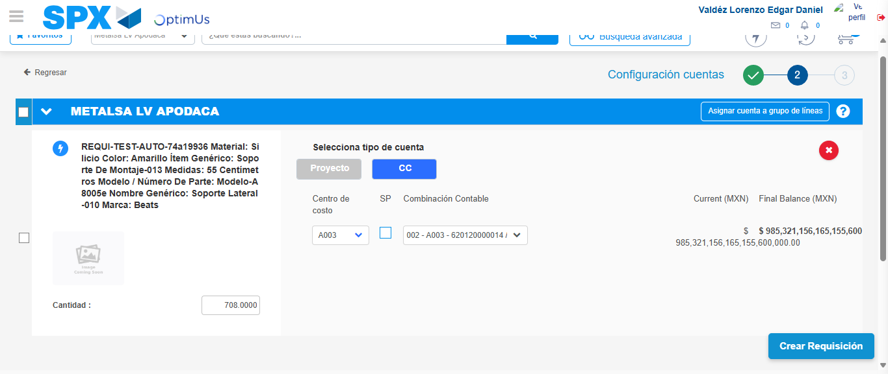Image file-name: QC_Testing-tc003_SPX_Dev5_Crear_Requisicion_Spot_Tipo_Cobro_CC_Urgent-1781572032605

Image file-name: QC_Testing-tc003_SPX_Dev5_Crear_Requisicion_Spot_Tipo_Cobro_CC_Urgent-1781572032783

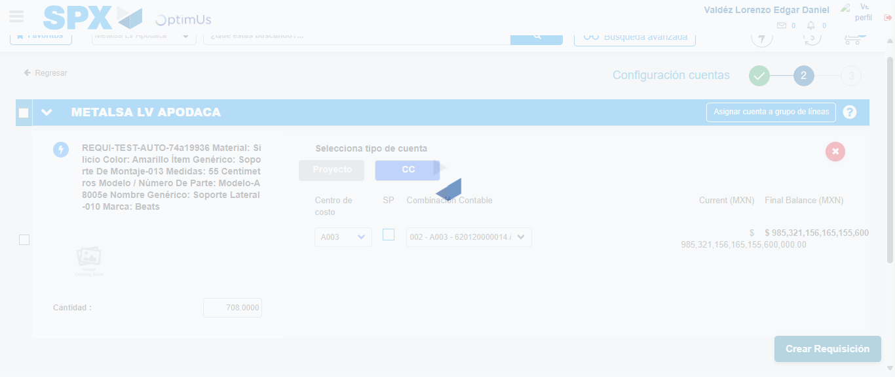Image file-name: QC_Testing-tc003_SPX_Dev5_Crear_Requisicion_Spot_Tipo_Cobro_CC_Urgent-1781572033151

Step 6 - Accept to Requisition: Requisition Accepted
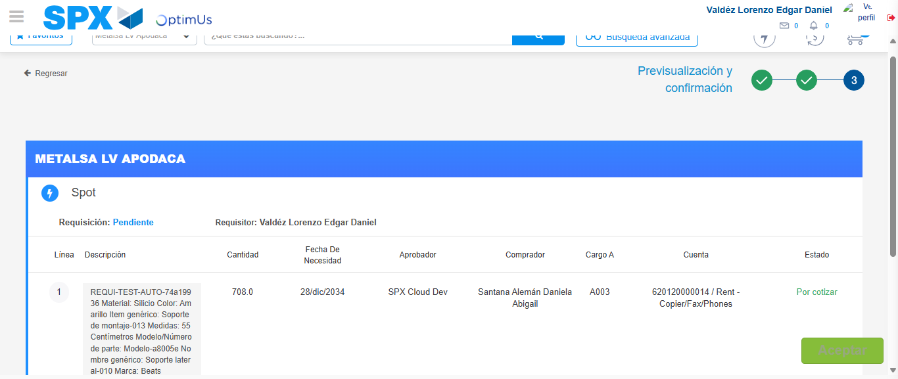Image file-name: QC_Testing-tc003_SPX_Dev5_Crear_Requisicion_Spot_Tipo_Cobro_CC_Urgent-1781572033933

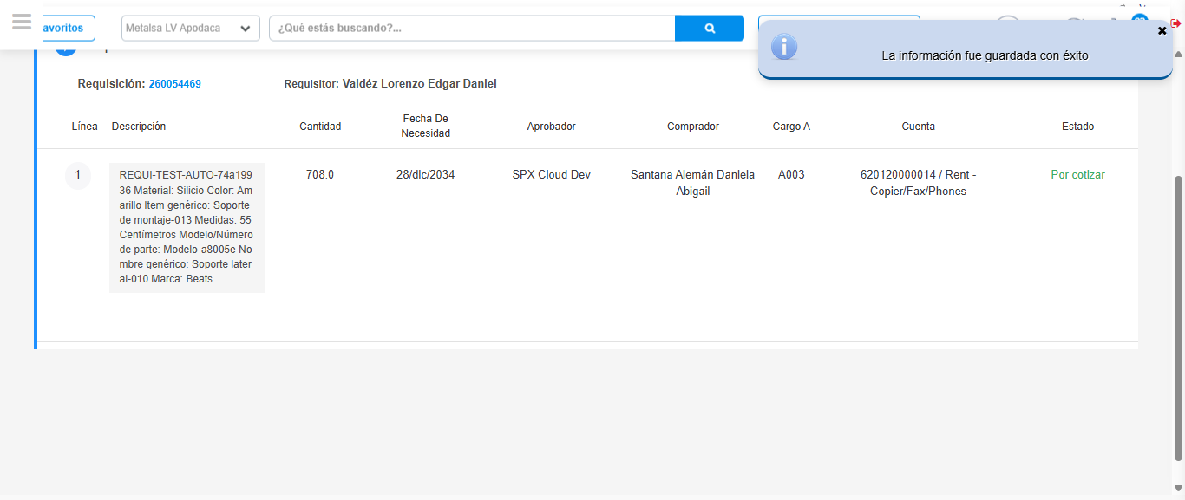Image file-name: QC_Testing-tc003_SPX_Dev5_Crear_Requisicion_Spot_Tipo_Cobro_CC_Urgent-1781572036380

Step 7 - Return to Main Page SPX : Return to Main Page SPX
Image file-name: QC_Testing-tc003_SPX_Dev5_Crear_Requisicion_Spot_Tipo_Cobro_CC_Urgent-1781571949088

Image file-name: QC_Testing-tc003_SPX_Dev5_Crear_Requisicion_Spot_Tipo_Cobro_CC_Urgent-1781571951604

Image file-name: QC_Testing-tc003_SPX_Dev5_Crear_Requisicion_Spot_Tipo_Cobro_CC_Urgent-1781571970530

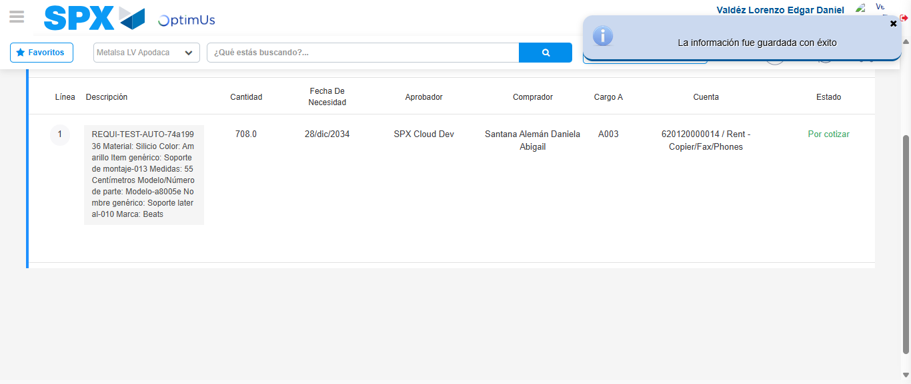Image file-name: QC_Testing-tc003_SPX_Dev5_Crear_Requisicion_Spot_Tipo_Cobro_CC_Urgent-1781572038593

Image file-name: QC_Testing-tc003_SPX_Dev5_Crear_Requisicion_Spot_Tipo_Cobro_CC_Urgent-1781572038766

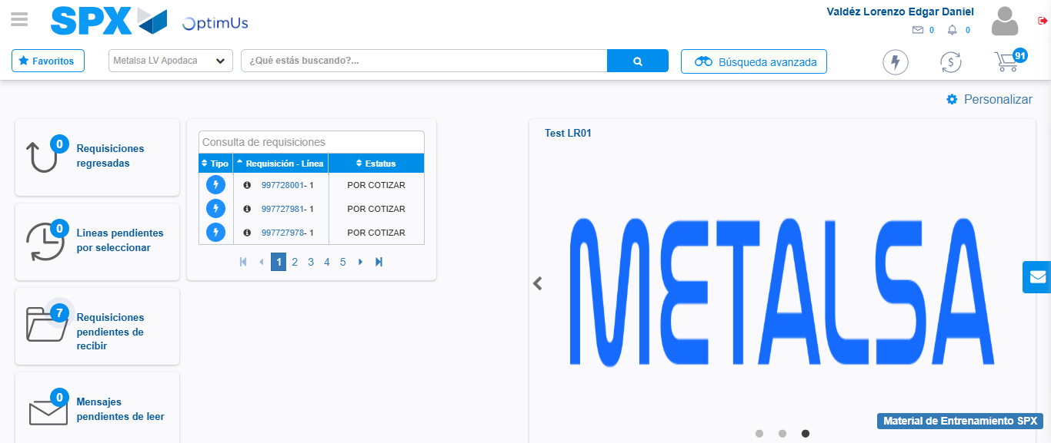Image file-name: QC_Testing-tc003_SPX_Dev5_Crear_Requisicion_Spot_Tipo_Cobro_CC_Urgent-1781572059763

Step 8 - Log Out : Log Out SPX
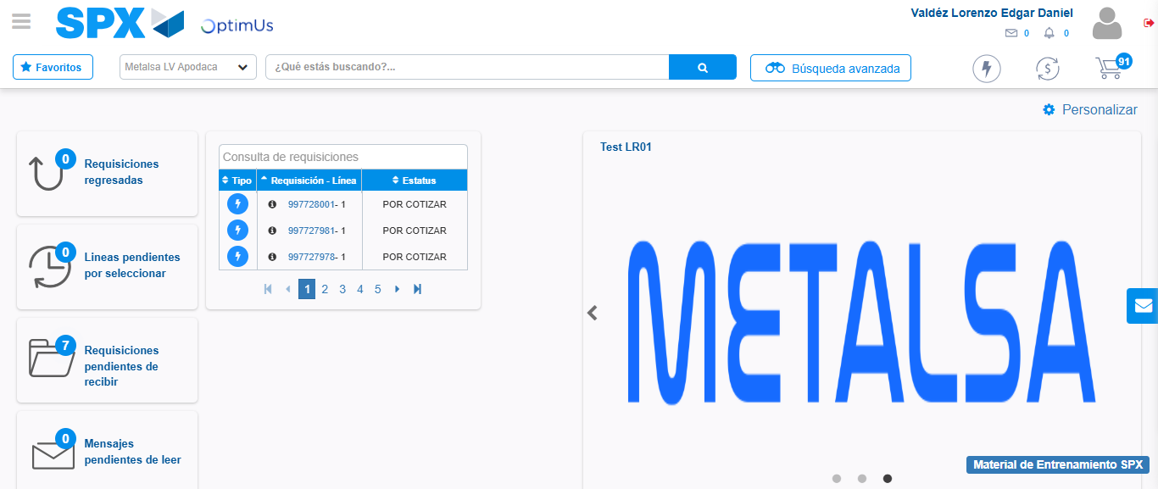Image file-name: QC_Testing-tc003_SPX_Dev5_Crear_Requisicion_Spot_Tipo_Cobro_CC_Urgent-1781572059995

